**Assignment 2**

Documentation for power query editor, data modelling and DAX functions

**Table Names:**

* Customers
* Product categories
* Products
* Product Subcategory
* Returns Data
* Sales data 2020
* Sales data 2021
* Sales data 2022
* Territory

**What I did?**

* Imported the data in power query editor

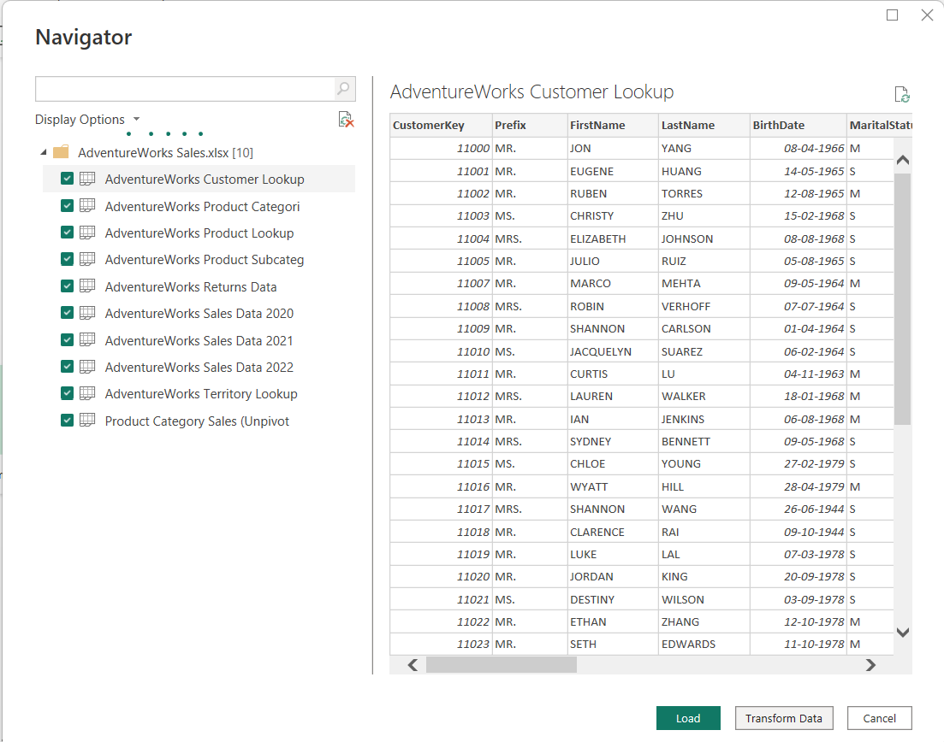

* Renamed Tables

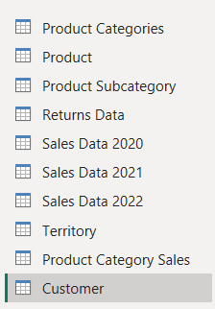

* Checked if datatypes are correct (eg. Decimal for currency, date for date, text for email, etc)
* Removed missing values and Duplicates from Product, territory and Customers tables

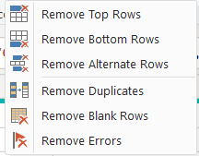

* Merged products and 2022 sales table based on product key, then merged the resultant table with customers table using customer key

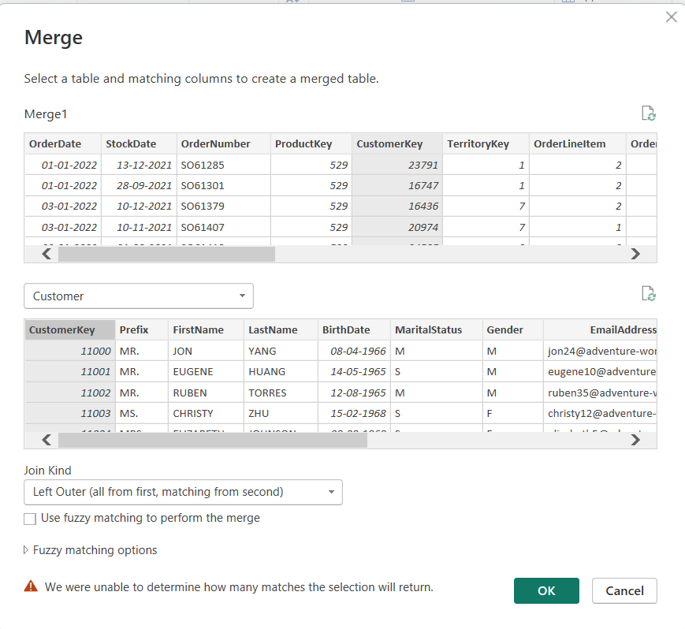

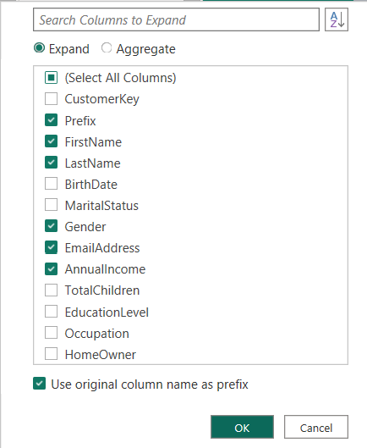

Applied the changes and closed power query editor

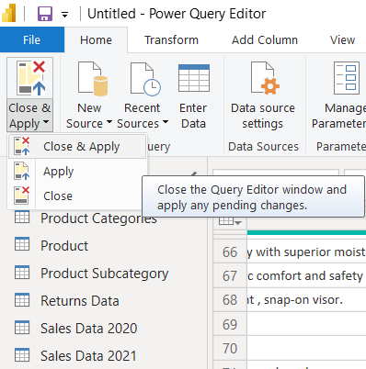

**Task 2: Data Modelling**

**Fact Table: Sales data 2022**

* + - Primary key – SalesOrderNumber
    - Secondary Keys- ProductKey, CustomerKey, TerritoryKey

**Dimension Tables:**

* **Product –** Primary key🡪 ProductKey
* **Customer –** Primary key 🡪 CustomerKey
* **Territory –** Primary key 🡪 TerritoryKey
* **Returns Data –** Primary key 🡪 ProductKey
* **High Value Customers –** Primary key 🡪 CustomerKey

**Final data model:**

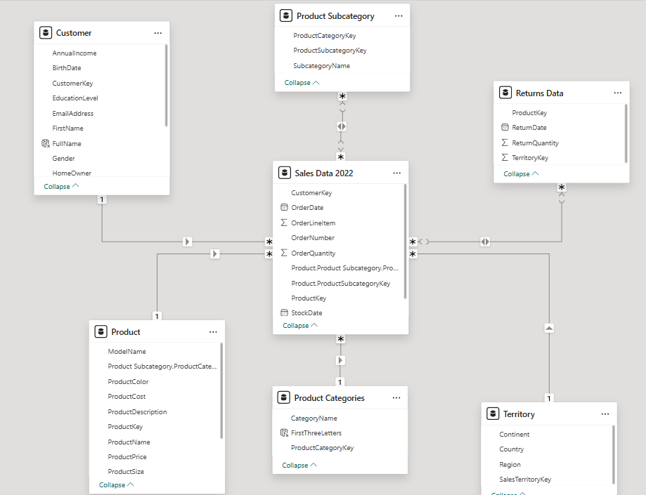

**Task 3: implementing DAX functions**

1. **Text functions**
2. Extracting first 3 letters of product category

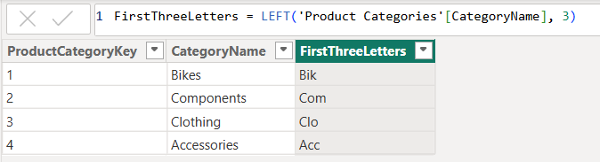

1. Create a full name column from First & Last Names:

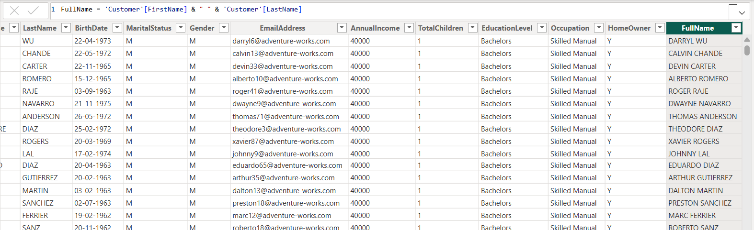

**B) Logical Functions**

**1.** Discount Category: Create a calculated column to categorize discounts

i. created TotalPrice column representing the total purchase amount by a customer



ii. Created a DiscountPercentage column based on values in TotalPrice column

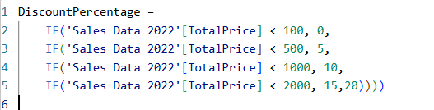

iii. created a discount column



2.High value customers

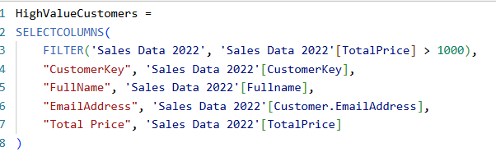

**C) Time & Intelligence Functions**

**1.** Calculate Total Sales Last Year:

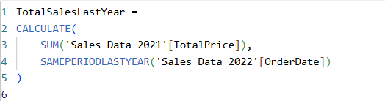

**2.** Year-to-Date (YTD) Sales:

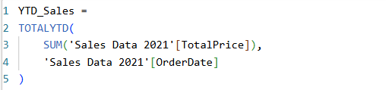

**3.**Month over month growth

**i.** created TotalSales measure



**ii.** created PreviousMonthSales measure



**iii.** calculated MoM absolute value



**iv.** calculated MoM growth percentage



**Task 4: Data Visualization & Report Creation**

1. Total sales by profit and quantity cards

Firstly create column representing the Total profit per item.





Create cards and plot other graphs:

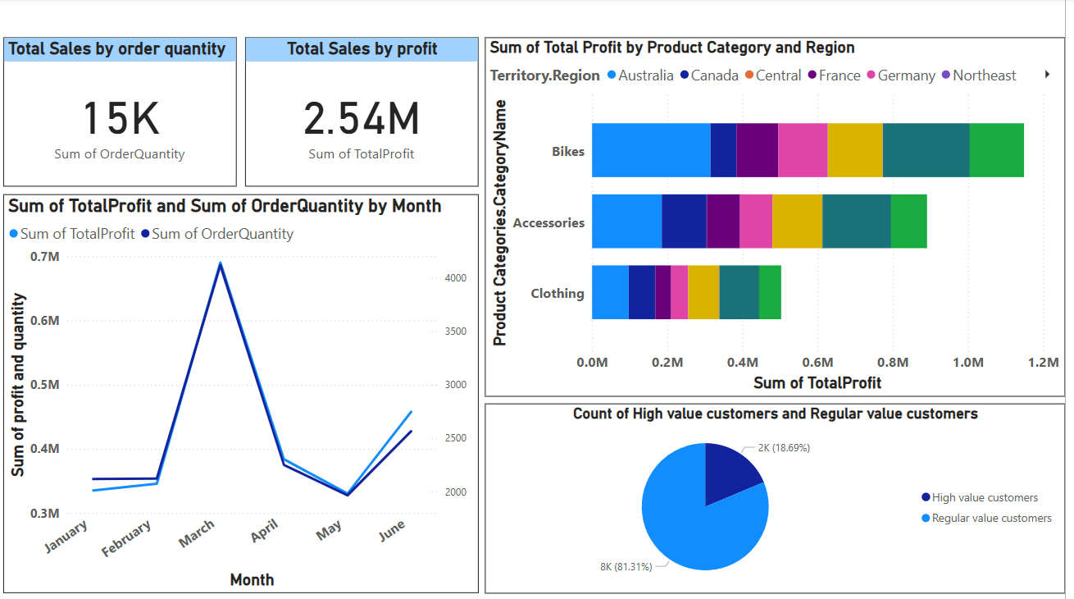

**Customer analysis dashboard:**

